# The Collective Exhibition Social Story

## TRAVEL

To get to the Meat Market in North Melbourne you can walk, use public transport or drive.

**Tram**

Catch Tram 58 or 59  to Stop 14 Royal Melbourne Hospital/ Flemington Road (accessible ramp tram stop with combination of low floor and stepped trams). A 300m walk or wheel from tram stop to The Stables down Wreckyn Street to the corner of Coutrney Street, North Melbourne.

**Train**  
Flagstaff Station – 15 minute walk  
Melbourne Central Station – 15 minute walk  
North Melbourne Station – 20 minute walk

**Bus**  
Bus 402 – Courtney/Wreckyn St stop  
Bus 401 and 403 – Royal Melbourne Hospital stop

**Cark Parking**

There are 2hr car parks directly out front of the venue on Courney and Wreckyn Streets. They may be paid or free depending on the time of day.

Two accessible carparks are located on Courtney Street close to the corner of Wreckyn Street. 3hrs 7.30am-6.30pm / no restriction all other times.

## LOCATION

Meat Market Stables

2 Wreckyn Street (corner of Wreckyn St and Courtney Streets), North Melbourne.

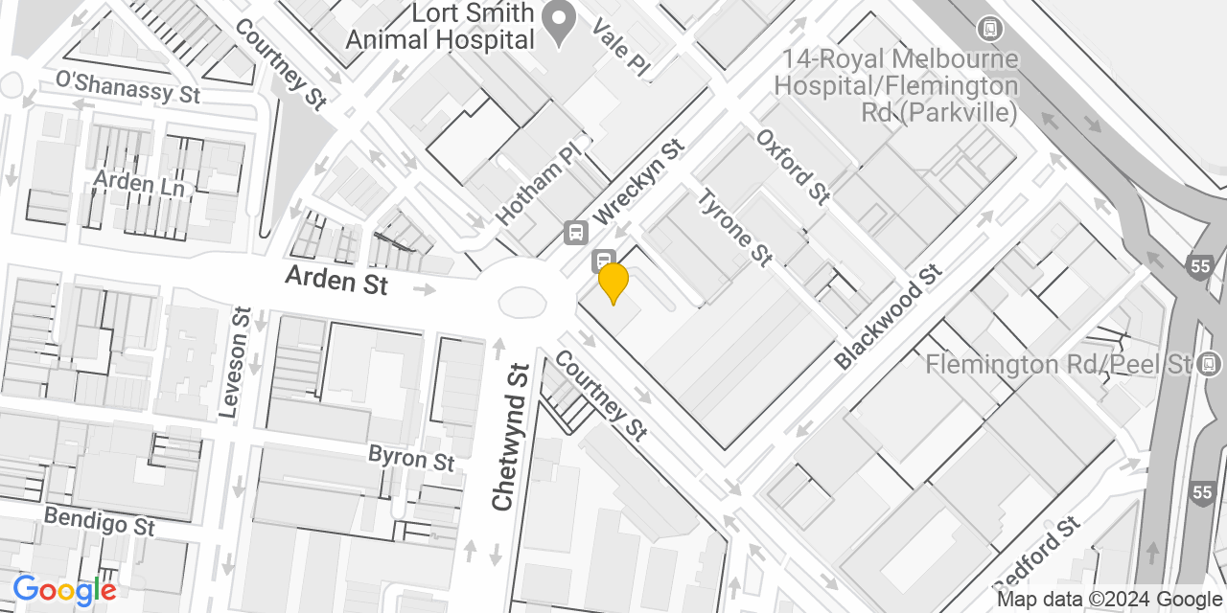

The Stables is a red brick warehouse on the corner of Wreckyn and Courtney Streets, North Melbourne. The Stables has pedestrian footpaths along both street sides, sloping up hill (medium incline) on Courtney Street and flat on Wreckyn Street. There are various maintenance hole covers along both footpaths and tactile tiles on the corner. The Stables can be entered from the Wreckyn Street entrance via the entrance door closest to the corner.  The door is a white double door inset into a larger opened rollerdoor.

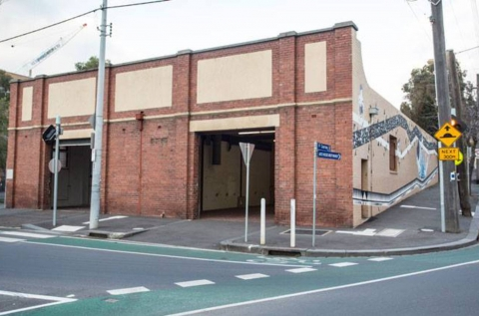

**Inside is a large space which has been divided into three zones.**

Upon entering the front entrance doorway you will be in the first room, the Welcoming Room. In this room you will be greeted by an AAV staff member who will share with you the various spaces and experiences inside the exhibition.

The Welcoming room has seating and AAV archive material; The Collective main exhibition room includes a multi screen audio/video installation (Auslan interpreter, captions, and audio description) of artworks from AAV past and present; and The Response room is a making space with tables, chairs and materials to participate. There will be a low sensory room in the Collective room and the Response room.

Audiences will have the opportunity to share their memories of AAV in the Response room. There will be a photo booth and materials to engage with and share memories.

**Access Information**

All bathrooms are gender neutral.

The accessible bathrooms are located at the far back corner of the main exhibition room at The Stables. The bathroom has handrails, room to manoeuvre a wheelchair and an accessible basin. There are baby change facilities.

A low sensory room can be found to the left as you enter The Stables inside The Collective room. The low sensory room has sound reduction earmuffs, low lighting, bean bags and fidget objects.

Assistance animals are welcome at Meat Market.

# **THE COLLECTIVE LAUNCH EVENT**

Friday 5 July, 4 pm – 7 pm

4-4.30pm

People arrive and gather in Welcoming space (entrance space with AAV archive material, food and drinks, light DJ Fina Po set)

4.30-5pm

Announcement, everyone to move in The Collective space for speeches.

5-6pm

Exhibition viewing (the exhibition is a large-scale dual screen audio/video installation displaying art projects over the past 50 years on one screen and then artists responses to each project on the second screen)

6-7pm

DJ Fina Po set in the Response room (bar and dancing)

There will be opportunity to socialise with other people at the event from 4pm when the doors open until 4.30 when the speeches start, and from 5.30 onwards while the DJ plays background music.

You can explore the Audio/Visual installation featuring work by over 100 artists.

Food and drinks will be available, including alcohol.

This is a mask friendly event. There is a low sensory space available which has headphones, low lighting, bean bags and fidget objects.

Arts Access Victoria staff will be on hand to offer any assistance you require. We will be able to be easily identified by our AAV badges.

Auslan interpreters will be translating the official speeches and will also be on hand for social interpretation from 4-7pm. Audio description of the space and the artworks will be accessible in the space via QR codes or can be found on our website.